Java Assignment 6

Name: Palak Kumari
Roll No: 25SCS1003001665
Course: B.Tech CSE
Subject: Java Programming

- Find Sum of Array Elements
Program-
import java.util.Scanner;

class SumArray {
public static void main(String[] args) {
Scanner sc = new Scanner(System.in);

System.out.print("Enter number of elements: ");
int n = sc.nextInt();
int[] arr = new int[n];
int sum = 0;
System.out.println("Enter array elements:");

for (int i = 0; i < n; i++) {
arr[i] = sc.nextInt();
sum = sum + arr[i];
}
System.out.println("Sum = " + sum);
}
}

Output-
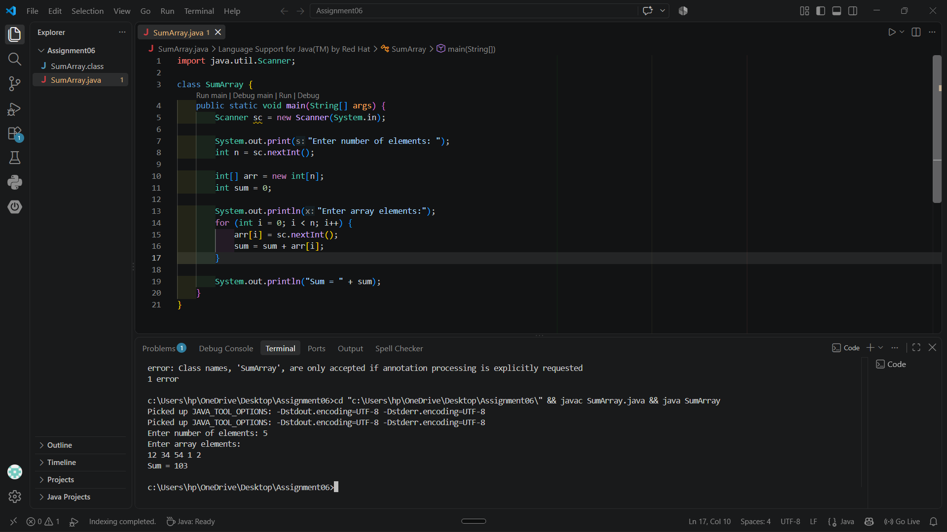
- Find Largest Element in an Array
Program-
import java.util.Scanner;

class LargestElement {
public static void main(String[] args) {
Scanner sc = new Scanner(System.in);

System.out.print("Enter number of elements: ");
int n = sc.nextInt();

int[] arr = new int[n];

System.out.println("Enter array elements:");
for (int i = 0; i < n; i++) {
arr[i] = sc.nextInt();
}

int largest = arr[0];

for (int i = 1; i < n; i++) {
if (arr[i] > largest) {
largest = arr[i];
}
}
System.out.println("Largest element = " + largest);
}
}
Output-
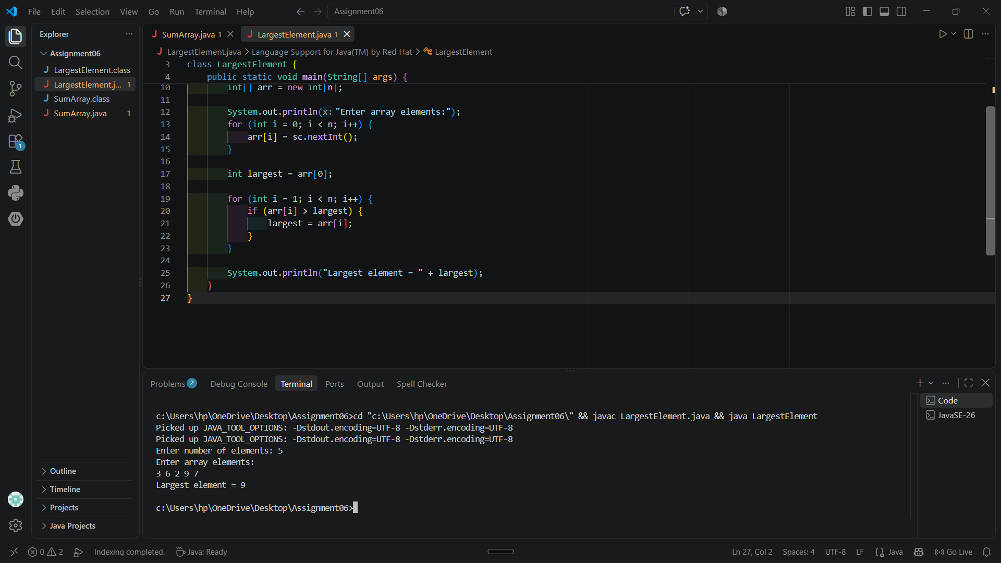

3-Search an Element in an Array
Program-
import java.util.Scanner;

class SearchElement {
public static void main(String[] args) {
Scanner sc = new Scanner(System.in);

System.out.print("Enter number of elements: ");
int n = sc.nextInt();

int[] arr = new int[n];

System.out.println("Enter elements:");
for (int i = 0; i < n; i++) {
arr[i] = sc.nextInt();
}
System.out.print("Enter element to search: ");
int x = sc.nextInt();
for (int i = 0; i < n; i++) {
if (arr[i] == x) {
System.out.println("Element found");
return;
} }
System.out.println("Element not found");
}
}

Output-
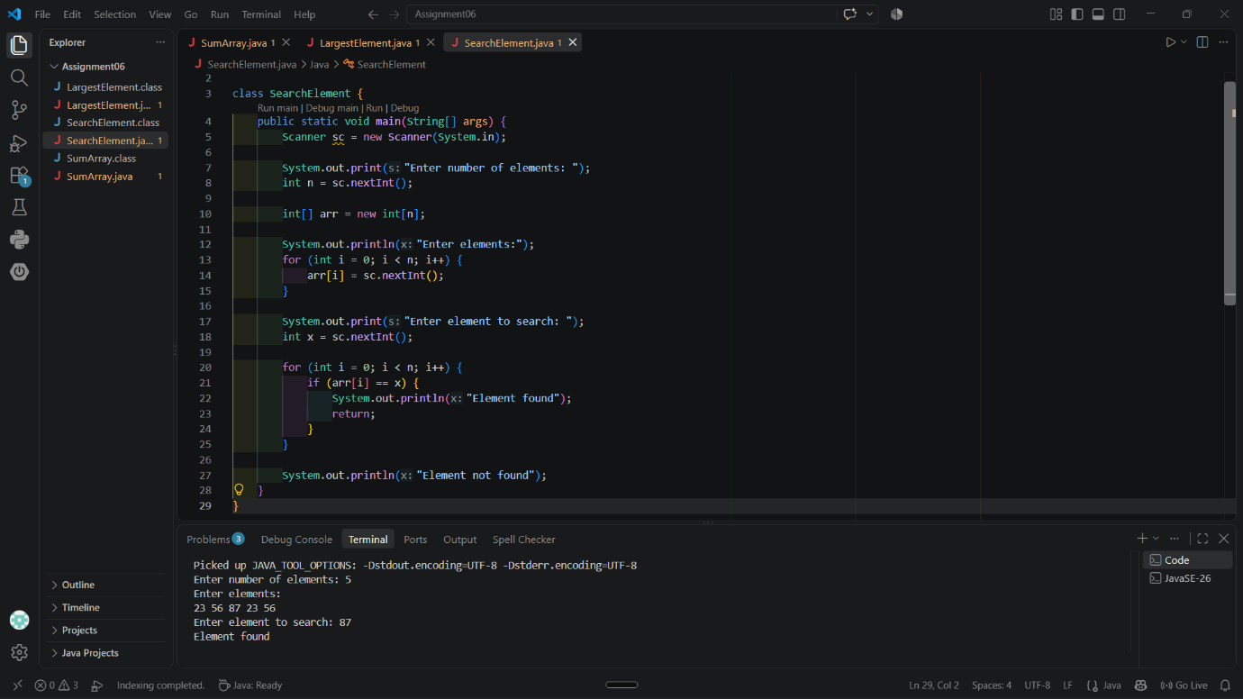

4-Reverse an Array
Program-
import java.util.Scanner;

class ReverseArray {
public static void main(String[] args) {
Scanner sc = new Scanner(System.in);

System.out.print("Enter number of elements: ");
int n = sc.nextInt();

int[] arr = new int[n];

System.out.println("Enter array elements:");
for (int i = 0; i < n; i++) {
arr[i] = sc.nextInt();
}

System.out.println("Reversed array:");

for (int i = n - 1; i >= 0; i--) {
System.out.print(arr[i] + " ");
}
}
}
Output-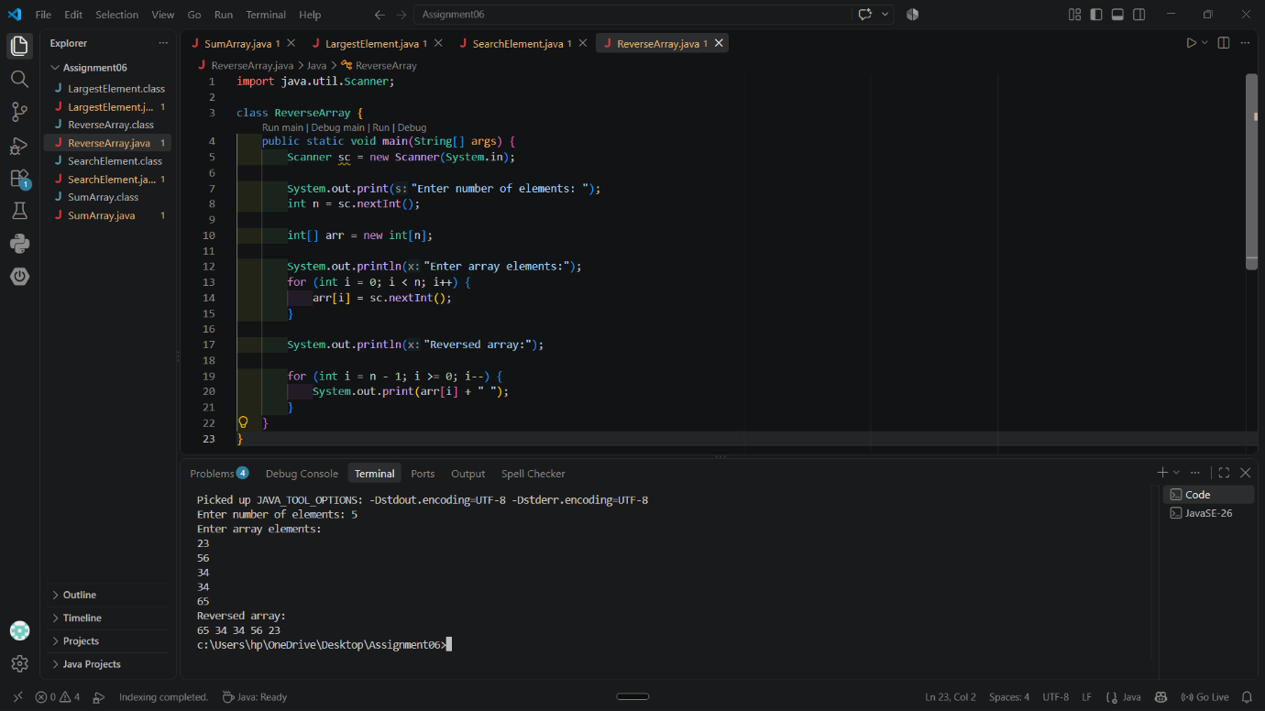

5-Count Occurrence of an Element in an Array
Program-
import java.util.Scanner;

class CountOccurence {
public static void main(String[] args) {
Scanner sc = new Scanner(System.in);

System.out.print("Enter number of elements: ");
int n = sc.nextInt();

int[] arr = new int[n];
System.out.println("Enter array elements:");
for (int i = 0; i < n; i++) {
arr[i] = sc.nextInt();
}

System.out.print("Enter element: ");
int element = sc.nextInt();
int count = 0;

for (int i = 0; i < n; i++) {
if (arr[i] == element) {
count++;
} }

System.out.println("Occurrence of " + element + " = " + count);
}
}

Output-
